Computer Language Diagrams

Class Referrers in a Diagram
The concept of class referrers was explained in the article Class Referrers.

Because the concept of referrers simply also functions as the concept of class referrers, it can be displayed in a diagram the same way, except, that classes and class references are displayed with dashed lines.

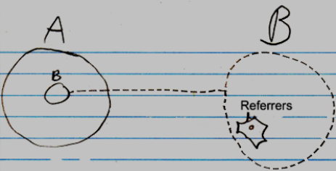

If the reference lines of the items in the Referrers list are displayed:

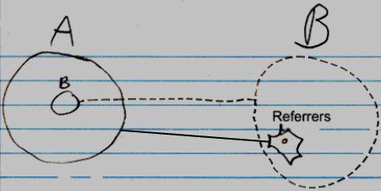

then they are displayed as solid lines, because thet are just references to the objects, that use it as a class. No implicit notation of making the referrer lines dashed will be used here, because that will introduce too much ambiguity in the diagram notaiton.

As mentioned in the article Referrers, it is not clear yet under which circumstances the whole referrers list might be completely left out of the diagram.

If a class defines that its objects support Referrers, but the class itself won’t register its Referrers, then the Referrers list of the class will be drawn out with dashed lines.

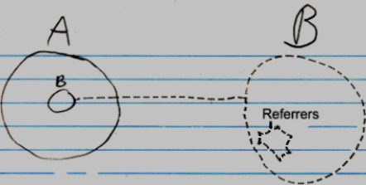

Obviously, the inactive referrers list will not contain any object references.

See also: Class Referrers, Referrers in a Diagram

Author & Copyright: Jan-Joost van Zon Date: June 15, 2008 – June 16, 2008 Location: Oosterhout, The Netherlands Status: Finished

